**Leader Overview**

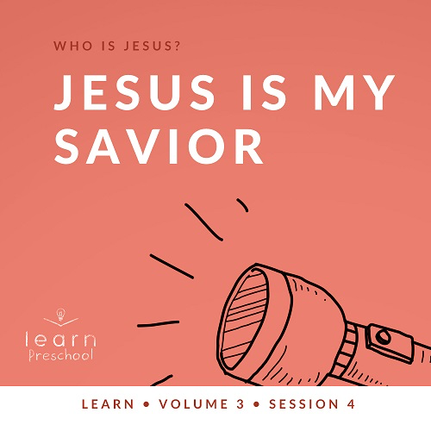

**Volume Overview**

**Who is Jesus?**

*In the classic book* Mere Christianity*, C. S. Lewis reasoned that those who refuse to believe Jesus’ claim to be God are left with the option of labeling Him as a lunatic or the devil. Jesus asked His closest followers who people thought He was (*[*Matthew 16:13*](https://ref.ly/logosref/Bible.Mt16.13)*). The disciples responded with far-ranging opinions. But then Jesus turned the question on them: “Who do you say I am?” Two thousand years later, there may not be a more important question for any of us to answer*.

**Session Overview**

**Jesus Is My Savior**

*In this* **Learn** *session, preschoolers will discover that Jesus forgives us when we sin. As they met at the lakeside, Jesus restored Peter after he denied knowing Jesus. This gospel of hope spans generations and speaks to the heart of our faith because Jesus forgives us, too. Jesus also wants us to forgive people who have hurt us*.

**Bible Lesson**

Jesus Forgives Peter

[John 21:1–19](https://ref.ly/logosref/Bible.Jn21.1-19)

**Faith Fact**

Jesus forgives.

**Faith Verse**

[John 3:16](https://ref.ly/logosref/Bible.Jn3.16) (NLT)

“For this is how God loved the world: He gave his one and only Son, so that everyone who believes in him will not perish but have eternal life.”

**Preparing for the Session**

**Leader Preparation Time: 20–25 Minutes**

|  |
| --- |
| ***You Will Need***  ***Preservice Activities***  *• Goldfish snack crackers*  *•* ***Preservice Activities Page***  *• Scissors*  ***Large Group***  *• Bible*  *• Worship songs (Song suggestions: “Praise the Lord Every Day” by Yancy, “Hosanna” by Yancy, “Super Wonderful God” by Yancy, “God, You Are Great” by Yancy)*  *• For groups not using a phone or tablet only, add:*  *• Projector or TV*  *• Laptop*  *•* ***Faith Fact Sound video*** *(bell ringing)*  *•* ***Faith Fact Slide***  *•* ***Faith Verse Slide***  *•* ***Bible Lesson Video A***  *•* ***Bible Lesson Video B***  *•* ***Response Time Page****, one for every four kids*  *• Scissors*  *• Crayons or pencils, one per kid*  ***Small Group***  *• One fish from the* ***Preservice Activities Page***  *• Optional: Logs and tissue paper*  *•* ***Small Group Activity Page****, one per kid*  *• Markers, one per kid*  *• Crayons*  *• Bean bags or rolled up socks, ten or more*  *• Fish net or basket*  *• Floor-safe tape*  *• Upbeat game music to play in background*  *• Balloons, one per group*  *• Permanent marker*  *To access session content and videos from a computer, visit:* [*BibleEngagementProject.com/downloads*](https://bibleengagementproject.com/Downloads) |
| ***Getting Ready***  ***Preservice Activities***  *• Print two copies of the* ***Preservice Activities Page****. Cut apart the pictures of the fish.*  *• Set out toys and snacks.*  ***Large Group***  *• Download videos and slides if needed.*  *• Select worship song(s) and have them ready to play.*  *• Print the* ***Response Time Page****, one copy for every four kids. Cut apart the boxes.*  ***Small Group***  *• Optional: Make a pretend campfire for the kids to gather around.*  *• Print copies of the* ***Small Group Activity Page****, one per kid.*  *• Set up net or basket.*  *• Place a line of tape on the floor about six feet from the net.*  *• Inflate the balloon(s).*  *• Draw the image on the balloon. When drawn correctly, the image will look happy or sad as you rotate the balloon.*  *• Draw a cross on the other side of the balloon.*  *First time leading* Learn *for Preschool? Check out the* [Facilitator Guide](https://0b769b0ed3569ef9d18b-f88d8272f61086866d50d048b43ef630.ssl.cf2.rackcdn.com/sites/biblengagementproject/Listen_Facilitator_Guide.pdf)*.* |

**Preservice Activities**

*See what’s needed at the beginning of the session.*

**Bible Story Warm-Up**

As we learn from the Bible today, we’ll discover a time when Jesus showed up while the disciples were fishing. I thought I’d bring some fish to help us get started.

• *Show the fish pictures to the kids*.

• *Then, lay out the fish pictures upside down on the table or floor*.

Jesus helped Peter and the other disciples catch a lot of fish. Let’s see how many we can catch. You’ll take turns trying to find two fish that match. We’ll keep playing until we’ve matched all the fish.

• *Ask these questions while the kids play*.

Have you ever been fishing?

Did you catch any fish?

Do you like to eat fish?

How many different pairs of fish did we find? Let’s count them.

**Snack**

**Goldfish Snack Crackers**

*As kids are eating the snack, share the following:*

There are a lot of fish in our Bible story today. Can you count how many fish you have? Do you have a pet fish? Fish are fun to watch as they swim. Do fish swim fast or slow?

**Free Play**

*Any extra time can be spent playing with toys*.

**Transition**

*A few minutes before service begins have kids make their way to the large group area and sit in their designated areas*.

**Large Group**

**25 Minutes**

*See what’s needed at the beginning of the session.*

**Introduction**

Hi, kids! I’m so excited that you’re here. We get to learn from the Bible today. The Bible tells us about Jesus. Today, we’ll learn that **Jesus forgives**.

**Faith Fact**

Have you ever had to say, “I’m sorry,” to someone? *(Group response)* Sometimes it can be hard to tell someone we’re sorry when we’ve hurt them. I’m very proud of you for doing that. Have you ever told someone you forgive them when they hurt you? *(Group response)* Those are hints about our Faith Fact today: **Jesus forgives**.

• *Show the* ***Faith Fact Slide***.



Let’s say our Faith Fact together. First, we’ll say it quietly. Then, we’ll say it louder and louder until we’re shouting it out. Ready? Can you whisper it? **Jesus forgives.** Say it a little louder. **Jesus forgives.** Say it a little louder again. **Jesus forgives.** Say it as loudly as you can. **Jesus forgives.** Great job! Let’s all clap for Jesus. *(Group response)*

**Bible Time**

I think Grandpa and Lizzy are ready to share the Bible story with us. Let’s see what they can tell us about Jesus today.

• *Play* ***Bible Lesson Video A***.

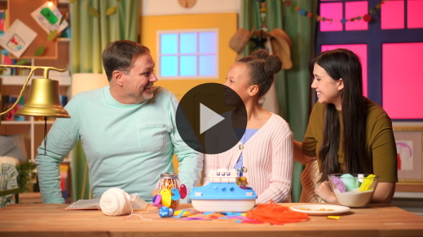

That was a great Bible story! Even though Peter did something bad, Jesus forgave him. That’s exactly what our Faith Fact says. Say it with me. **Jesus forgives.** That’s so wonderful that I think we should shout it. **Jesus forgives**.

**Worship**

When we follow Jesus and do what the Bible says, we’re showing Him how much we love Him. Another way we can show Jesus how much we love Him is by praising Him. Let’s do that now.

**Praise**

Are you glad Jesus loves you? Touch your toes down low. *(Group response)*

Are you thankful Jesus forgives you? Clap your hands three times. *(Group response)*

Who wants to thank Jesus? Wave your hands up high. *(Group response)*

**Sing**

Now, let’s show Jesus we love Him by singing.

• *Lead the kids in singing one or two songs. See song suggestions at the beginning of the session*.

**Prayer**

Let’s pray together.

|  |
| --- |
| Dear Jesus, thank You for loving us. Sometimes we do things that hurt You just like Peter did. Thank You for forgiving us when we ask. Amen. |

**Bible Time cont’d**

It’s time to check back in with Lizzy and Grandpa. I think they’re going to help us review our Faith Verse.

• *Play* ***Bible Lesson Video B***.

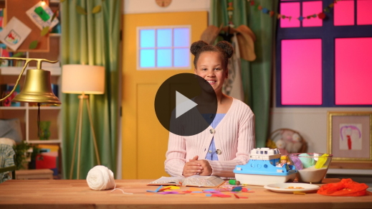

You’re getting our Faith Verse. I’m so glad. It tells us how much God loves us.

**Response Time**

• *Play a worship song quietly*.

Today, we learned that Jesus forgave Peter. Remember, Peter had hurt Jesus by saying wrong things. Jesus took Peter’s sad feeling away and reminded Peter that He loved him.

Jesus can do the same for us. When we hurt Jesus or someone else, we feel bad on the inside. Let’s draw a picture of how you feel when you do something wrong.

• *Give each kid a rectangle from the* ***Response Time Page*** *and a crayon or pencil. Pause for kids to draw*.

Jesus knows how sad we can feel when we do something wrong. He loves us. Jesus can take away the sad feeling that we have just like He did for Peter. He can help us to feel better if we ask Him to forgive us. When we give our sins to Jesus, He forgives us just like He forgave Peter.

Hold your paper out like you are giving your sadness to Jesus. Let’s pray.

• *While most preschoolers may not get the concept of salvation, this Response Time can be an introduction to a relationship with Jesus. Be aware that a few kids may spiritually connect in this moment*.

|  |
| --- |
| Jesus, thank You for being our Savior. Thank You for loving us. We know we sometimes hurt You. We’re sorry. Please forgive us. Amen. |

**Faith Verse**

Talking about how much Jesus loves us reminds me of our Faith Verse. Let’s say our Faith Verse and do the actions together.

[John 3:16](https://ref.ly/logosref/Bible.Jn3.16) (NLT)

“For this is how God loved the world: He gave his one and only Son, so that everyone who believes in him will not perish but have eternal life.”

• *Show the* ***Faith Verse Slide***.

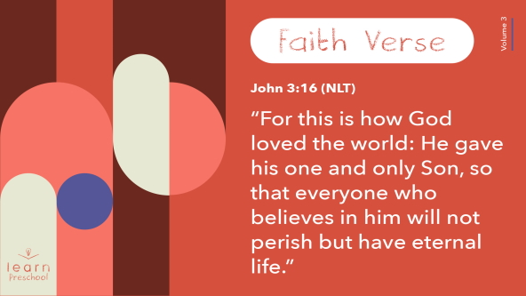

**John** *(hands at waist, spread apart, palms up and out)*

**3:** *(hands together like a clap)*

**16** *(hands opened to “book”)*

**“For this is how God** *(two index fingers point up)*

**loved the world:** *(two hands covering heart)*

**He gave his one and only Son**, *(hold up one finger)*

**so that everyone who believes in him** *(palms up, move hands away from body and out)*

**will not perish** *(make fists, bend elbows, and cross arms as they go down and away from body)*

**but have eternal life.”** *(make L with index fingers and thumbs and move arms up sides of body)*

You’re so awesome! You’re doing such a good job with our Faith Verse.

**Closing**

Today has been a special day because we learned that **Jesus forgives**. It’s great to know Jesus loves us so much.

• *Play* ***Faith Fact Sound*** *video (bell ringing)*.

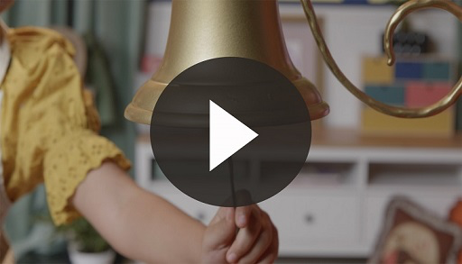

That sound means it’s time to practice our Faith Fact one more time: **Jesus forgives**.

• *Show the* ***Faith Fact Slide***.



Let’s shout it together. Ready? **Jesus forgives.** Raise your hands above your head and say it. **Jesus forgives**. Let’s thank Jesus for forgiving us. *(Group response)*

**Dismissal to Small Groups**

Thanks for learning more about Jesus with me. Now, it’s time to go to our circles where we’ll spend time in our very special small groups.

• *Dismiss the kids by groups.*

|  |
| --- |
| ***Leader Tip:*** *This can be done by assigning color teams or by age groups. Note that some young preschoolers may not know their age. Using a colored sticker, jersey, or wristband will help separate the kids and help identify their small groups.* |

**Small Group**

**25 Minutes**

*See supplies and prep instructions at beginning of session or in each activity below.*

|  |
| --- |
| ***Leader Tip:*** *Small groups can alternate to each circle, or all groups can do each activity at the same time. If you choose to alternate, you will need at least one leader per circle.* |

**Circle 1**

**Group Connection**

**Campfire Connection**

|  |
| --- |
| ***You Will Need***  *• One fish from the* ***Preservice Activities Page***  *• Optional: Logs and tissue paper*  ***Getting Ready***  *• Optional: Make a pretend campfire for the kids to gather around.* |

When His friends were fishing, Jesus showed up on the shore. He made a campfire and called His friends to join Him. Let’s sit together just like Jesus and His friends did.

• *Optional: If you made a pretend campfire, invite the kids to sit down around the fire with you*.

Have you ever sat around a campfire like Jesus and His friends did? *(Group response)* Have you roasted marshmallows, hot dogs, or some other food at the campfire? *(Group response)* What did Jesus cook for His friends by the fire? *(Allow responses.)*

• *Hold up the fish picture*.

Jesus and His friends ate together. Let’s pretend we’re passing the fish to our friends. Let’s say this rhyme as we share the food: Hot fish, hot fish, who’s got the hot fish?

When we finish saying the rhyme, we’re going to freeze in place. If you’re holding the fish, you’ll get to say our Faith Fact: **Jesus forgives.** Then, we’ll keep playing. Let’s play!

• *Repeat until everyone has had a chance to say the Faith Fact or time runs out*.

You know, Jesus forgave Peter because Jesus loved His friends. Jesus loves you and me, too. He always forgives us when we ask Him.

**Circle 2**

**Activity Page Time**

**Find the Fish**

|  |
| --- |
| ***You Will Need***  *• Markers, one per kid*  *• Crayons*  ***Getting Ready***  *• Print copies of the* ***Small Group Activity Page****, one per kid.* |

Jesus helped His friends catch a lot of fish. There are a lot of fish on our page today.

• *Hand out the* ***Small Group Activity Page****, crayons, and markers.*

All the fish are exactly alike except for one fish. Can you find the fish that is different from the others? When you find it, circle it with the marker. Then, color all the fish with bright colors.

Because Peter had hurt Jesus, he might have felt different from Jesus’ other friends. Can you show me how you think Peter looked when he knew he had hurt Jesus? *(Group response)*

How do you think Peter felt when he saw Jesus again? *(Allow responses.)*

Show me how you think Peter might have looked after Jesus forgave him. *(Group response)*

After Jesus had talked with Peter and forgave him, I think Peter was happy again. It can be hard to say we’re sorry, but after we do, we feel better on the inside. We probably look happier on the outside, too.

**Circle 3**

**Feet-to-Floor Game Time**

**Fish Catch**

|  |
| --- |
| ***You Will Need***  *• Bean bags or rolled up socks, ten or more*  *• Fish net or basket*  *• Floor-safe tape*  *• Upbeat game music to play in background*  ***Getting Ready***  *• Set up net or basket*  *• Place a line of tape on the floor about 6 feet from the net.* |

Jesus’ friends fished all night long, but they didn’t catch any fish. Then, Jesus told them to put their nets in the water on the other side of the boat. Guess what! Jesus helped the disciples catch 153 fish. That’s a lot of fish!

Let’s see how many fish we can catch. You’re going to take turns tossing our pretend fish into the net.

• *Have kids take turns tossing the bean bags or socks into the net. Keep playing until they have caught all the fish*.

• *Adjust the starting line as needed to make the game challenging, but fun*.

• *During the activity, interrupt and practice the Faith Fact:* **Jesus forgives**.

• *Play* ***Faith Fact Sound*** *video. Review the Faith Fact even if you can’t play the sound*.



Jesus and His friends had a good time together on their fishing day. Most importantly, Jesus forgave Peter. I love our Faith Fact: **Jesus forgives**.

**Circle 4**

**Hands-On Learning**

**Sad to Happy**

|  |
| --- |
| ***You Will Need***  *• Balloons, one per group*  *• Permanent marker*  ***Getting Ready***  *• Inflate the balloon(s).*  *• Draw the image below on the balloon. When drawn correctly, the image will look happy or sad as you rotate the balloon.*  *• Draw a cross on the other side of the balloon.* |

We know that Peter was sad when he hurt Jesus. *(Show the sad face on the balloon.)*



After Jesus forgave Peter, I think he was very happy. *(Turn the balloon to show the happy face.)*



That’s because our Faith Fact is true. Say it with me. **Jesus forgives.** Jesus forgives ______________. *(Name each kid in your group.)*

• *Show the cross side of the balloon*.

Jesus loves each one of us so much that He was willing to be hurt on the Cross. He did that so our sin can be forgiven. That’s what our Faith Verse says. Let’s say it together with the motions we have learned.

**John** *(hands at waist, spread apart, palms up and out)*

**3:** *(hands together like a clap)*

**16** *(hands opened to “book”)*

**“For this is how God** *(two index fingers point up)*

**loved the world:** *(two hands covering heart)*

**He gave his one and only Son**, *(hold up one finger)*

**so that everyone who believes in him** *(palms up, move hands away from body and out)*

**will not perish** *(make fists, bend elbows, and cross arms as they go down and away from body)*

**but have eternal life.”** *(make L with index fingers and thumbs and move arms up sides of body)*

Jesus made it possible for us to live forever with Him someday. That makes me very happy. How about you? *(Group response)*

• *Optional: If you have kids in your group who understand what it means to ask Jesus in their life, this is a good time to explain salvation and pray with them*.

**Dismissal**

• *Play* ***Faith Fact Sound*** *video (bell ringing).*



• *Show the* ***Faith Fact Slide***.



Do you remember what that sound means? *(Group response)* Let’s say the Faith Fact together one last time. **Jesus forgives**. Great job! I had a great time learning more about Jesus with you. I’m so glad He forgives you and me. See you next time!

• *Send home the* ***Small Group Activity Page*** *and the* ***Response Time*** *drawing with each kid*.

• *Remind parents that there are* ***Family Devotions*** *available on the app to do with their kid*.

• *Tell everyone the date and time for the next session*.

.